CARBINE 31.
a) Slack too soft.
-- Filing the opposite part of the pin at "1" deeper (fine
-- sandpaper around a round a suitable round file or wire).
b) Slack is hauling.
-- Filing very few away with a flat file and fine sandpaper at
-- point "2" of the receiver "3".
-- It is prohibited to do any changes to the sear and cocking
-- piece notch as well as to the trigger and firing pin spring
-- ( to avoid shooting accidents).
-- THE ARMORER IS PROHIBITED TO DO ANY SLACK SETTING
-- JOBS OFF-DUTY.
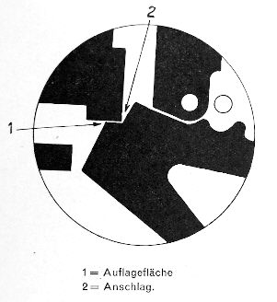
c) When the trigger is pushed forward the cocking piece is released.
-- Filing down "1" in this last drawing of the trigger a bit.

